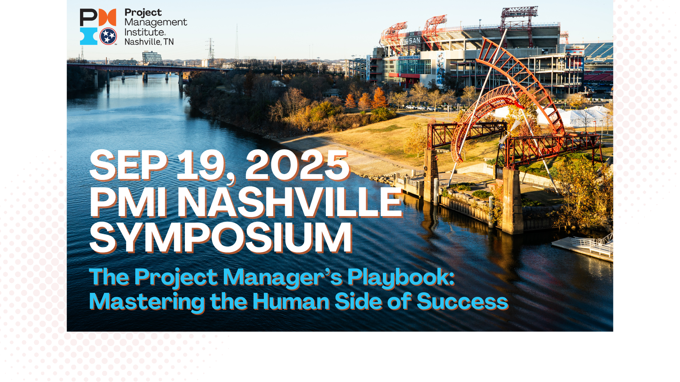
Subject: Request to Attend PMI Nashville Symposium 2025 – Sept 19
Hello [Manager's Name],
I’d like to request approval to attend and have expenses covered for the PMI Nashville Symposium 2025 on Friday, September 19, an all-day conference here in Nashville, TN.
This one-day, high-impact conference is designed to strengthen project leadership, communication, and team-building skills—core areas that directly support our work and team goals. The theme this year is “Project Manager’s Playbook: Mastering the Human Side of Success,” with a focus on leadership soft skills like emotional intelligence, stakeholder communication, and team motivation.

Here’s what I’ll gain from attending:
- Expert-led keynotes from leadership coaches and industry trailblazers
- Interactive breakout sessions on conflict resolution, inclusive leadership, mental fitness, and more
- Professional Development Units (PDUs) toward my PMP or other PMI certifications
- Networking with a wide range of project professionals across industries
- Takeaways that I can bring back to strengthen our project outcomes and team dynamics
The total cost of attendance is $200 until July 24 for PMI Nashville members, and then the price goes up to $250 which is also the price for non - PMI Nashville members. This registration cost includes access to all sessions, meals, giveaways, and learning materials. The venue is local: Embassy Suites Nashville, so there are no overnight travel expenses required.
I’m confident this event will provide real, applicable strategies I can bring back to the team. I’d also be happy to share a summary of key learnings and resources afterward.
Thanks for considering this request! Let me know if you’d like any additional info or if there's a form I should complete.
Best regards,
[Your Name]
[Your Title / Team Name]

